Batch:___B1__ Roll No.:_1411072_
Experiment No. 3
Grade: AA / AB / BB / BC / CC / CD /DD

Signature of the Staff In-charge with date

Title: Packet Analyser

Objective:
To sniff incoming packets, decode it and display and analyse the contents of TCP and IP headers.

Expected Outcome of Experiment:

CO | Outcome
CO1
  Explain various security goals, threats, vulnerabilities and controls

Books/ Journals/ Websites referred:

1. Behrouz A Fourouzan, Debdeep Mukhopadhyay, “Cryptography and Network”, 2nd edition, TMH.
2. Bernard Menezes, “Network Security and Cryptography”, 2nd edition, Cengage Learning..
3. William Stallings, “Cryptography and Network Security: Principles and Practice” 5th edition, , Pearson
4. Binary Tides - http://www.binarytides.com/python-packet-sniffer-code-linux/

Abstract:-
This experiment aims to help students understand the TCP/UDP/IP header formats, so they gain an insight into what kind of information can be visible to an intruder who manages to sniff network packets of any communication.
This is to be achieved by implementing a packet sniffer and analyser from scratch.

Related Theory: -
IP Header:
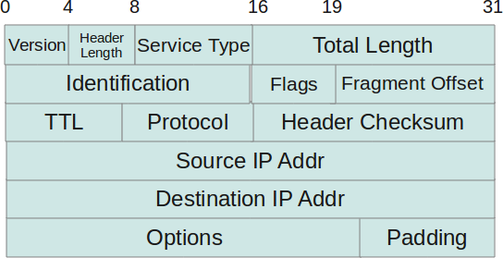

TCP Header:
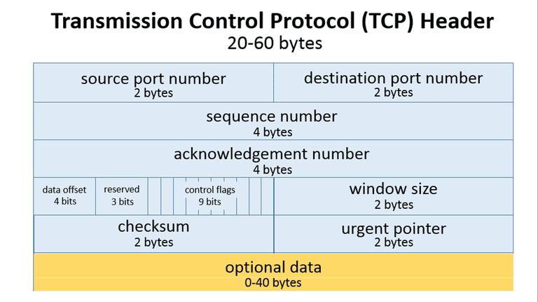

Implementation Details:
- Code is written in java.
- It uses winpcap and jpcap to sniff packets
- Following classes are used from jpcap:
  - IPPacket
We get the information regarding the protocol used, fragmentation, Source & Destination IP Address, Hop count (TTL), Priority, Reliability, and type of service of packet

  - TCPPacket
We get information regarding TCP version, Source & Destination IP and destination port number.
  - ICMPPacket
We get information regarding Source & Destination IP address, TTL value, subnet mask used and Checksum and also information about various flags in ICMP.
  - UDPPacket
We get the source and destination port.
  - EthernetPacket
We get the source & destination address of the packet.
- We can sniff a particular type of packet or all packets, as desired from any available network device.

CODE:
import jpcap.*;
import jpcap.NetworkInterface;
import jpcap.packet.DatalinkPacket;
import jpcap.packet.EthernetPacket;
import jpcap.packet.ICMPPacket;
import jpcap.packet.IPPacket;
import jpcap.packet.Packet;
import jpcap.packet.TCPPacket;
import jpcap.packet.UDPPacket;
import java.util.Scanner;

class Sniffer implements PacketReceiver{
/**
* @param type_of_packet: This field conatins the information about which packet type you want to track. Eg. TCP.
* @param protocoll: This is an array consisting of all protocols linked with the protocol field of the packet.
*/
static String type_of_packet = "TCP";
static String protocoll[] = {"HOPOPT", "ICMP", "IGMP", "GGP", "IPV4", "ST", "TCP", "CBT", "EGP", "IGP", "BBN", "NV2", "PUP", "ARGUS", "EMCON", "XNET", "CHAOS", "UDP", "mux"};

public void receivePacket(Packet packet){
System.out.println(packet);

IPPacket ip_packet = (IPPacket) packet;

/**
* Following are the fields that I used from IP Packet.
*
* protocol: This provides an integer corresponding to protocol type. This is linked with protocoll array to get actual type of protocol.
* dont_frag: This is a boolean value, says if the DO NOT FRAGMENT bit is set/not set.
* src_ip: Source IP Address.
* dst_ip: Destination IP address.
* hop_limit: Gives hop count.
* priority: Gives priority.
* rsv_tos: Type of service included in packet header.
* r_flag: Specifies if the connection used is reliable or not.
* version: Protocol version.
*/

if(packet!=null){
int protocol_number = ip_packet.protocol;
String protocol = protocoll[protocol_number];
if(type_of_packet.equals("All") || protocol.equals(type_of_packet)){
System.out.println("---------- From Network Layer ----------\n");
if(ip_packet.dont_frag){
System.out.println("\n\tDo not fragment bit is set. Packet may not be fragmented.");
}else{
System.out.println("\n\tDo not fragment bit is not set. The packet may be fragmented.");
}
System.out.println("\n\tSource IP Address: "+ip_packet.src_ip);
System.out.println("\n\tDestination IP Address: "+ip_packet.dst_ip);
System.out.println("\n\tHop count: "+ip_packet.hop_limit);
System.out.println("\n\tPacket length: "+ip_packet.length);
System.out.println("\n\tPacket priority: "+(int)ip_packet.priority);
System.out.println("\n\tType of service: "+ip_packet.rsv_tos);
if(ip_packet.r_flag){
System.out.println("\n\tPacket uses reliable transmission.");
}else{
System.out.println("\n\tPacket uses unreliable transmission.");
}
System.out.println("\n\tProtocol version: "+(int)ip_packet.version);

if (protocol.equals(("TCP"))) {
/**
* Documentation for fields used from TCP Packet
*
* dst_port: Destination port number.
* version: TCP Version.
* dst_ip: Destination IP Address.
* src_ip: Source IP Address.
*
* -- Flag based fields --
* ack: Boolean value stating if ACK (Is Acknowledgement?) flag is set in TCP Header.
* fin: Boolean value stating if FIN (Is Last packet?) flag is set in TCP Header.
* syn: Boolean value stating if SYN (Is Synchronisation packet?) flag is set in TCP Header.
*/

TCPPacket tp = (TCPPacket) packet;

System.out.println("\n\t```````````` TCP packet ````````````");
System.out.println("\n\tDestination port: " + tp.dst_port);

if (tp.ack) System.out.println("\n\tThis is an acknowledgement packet");
else System.out.println("\n\tThis is not an acknowledgment packet");

if (tp.rst) System.out.println("Connection reset packet");

System.out.println("\n\tProtocol version: " + tp.version);
System.out.println("\n\tDestination IP Address: " + tp.dst_ip);
System.out.println("\n\tSource IP Address: "+tp.src_ip);

if(tp.fin) System.out.println("\n\tNo more packets to be transferred. Finish bit is set.");
if(tp.syn) System.out.println("\n\tThis is a request for connection.");

}
else if(protocol.equals("ICMP")){
/**
* Documentation for fields used from ICMP Packet
*
* alive_time: TTL field value.
* subnetmask: Subnet Mask used.
* src_ip: Source IP Address.
* dst_ip: Destination IP Address.
* checksum: Checksum value from Header.
*/

ICMPPacket ipc=(ICMPPacket)packet;

System.out.println("\n\t```````````` ICMP packet ````````````");
System.out.println("\n\tTTL time: "+ipc.alive_time);
System.out.println("\n\tSubnet mask: "+ipc.subnetmask);
System.out.println("\n\tSource IP address: "+ipc.src_ip);
System.out.println("\n\tDestination IP address: "+ipc.dst_ip);
System.out.println("\n\tChecksum: "+ipc.checksum);
}
else if(protocol.equals("UDP")){
/**
* Documentation for fields used from UDP Packet
*
* src_port: Contains Source Port number.
* dst_port: Contains Destination port number.
*/

UDPPacket pac=(UDPPacket)packet;

System.out.println("\n\t```````````` UDP packet ````````````");
System.out.println("\n\tSource port: "+pac.src_port);
System.out.println("\n\tDestination port: "+pac.dst_port);
}

System.out.println("\n--------------------- From Datalink layer ---------------------");
DatalinkPacket dp = packet.datalink;

EthernetPacket ept=(EthernetPacket)dp;

/**
* Documentation for methods used from EthernetPacket class.
*
* getSourceAddress(): Returns source address of packet.
* getDestinationAddress(): Returns Destination address of packet.
*/
System.out.println("\n\tSource MAC Address: "+ept.getSourceAddress());
System.out.println("\n\tDestination MAC Address: "+ept.getDestinationAddress());
}
}
}

public static void main(String[] args) throws Exception{
Scanner sc = new Scanner(System.in);
NetworkInterface[] devices = JpcapCaptor.getDeviceList();

for (int i = 0; i < devices.length; i++) {
System.out.println(i + " :" + devices[i].name + "(" + devices[i].description + ")");
System.out.println(" data link:" + devices[i].datalink_name + "("
+ devices[i].datalink_description + ")");
System.out.print(" MAC address:");
for (byte b : devices[i].mac_address) {
System.out.print(Integer.toHexString(b & 0xff) + ":");
}
System.out.println();
for (NetworkInterfaceAddress a : devices[i].addresses) {
System.out.println(" address:" + a.address + " " + a.subnet + " "
+ a.broadcast);
}
}

System.out.println("Total "+protocoll.length+" protocols.");
System.out.println("Below are all Network Layer protocols which can be sniffed: ");
int i=1;
for(String each_protocol: protocoll){
System.out.println(i++ + ": "+each_protocol);
}
System.out.println(i + ": All");
while(true){
System.out.print("\nEnter the index for your desired protocol: ");
int index = sc.nextInt();
if(index <= protocoll.length){
type_of_packet = protocoll[index-1];
break;
}
else if(index == protocoll.length + 1){
type_of_packet = "All";
break;
}
System.out.println("Sorry. Please refer the above table and re-enter your index.");
}

System.out.println("Type of packets to be sniffed: "+type_of_packet+"\n");

System.out.println("\n--------------------- Packet sniffing starts now ---------------------");
JpcapCaptor jpcap = JpcapCaptor.openDevice(devices[2], 2000, true, 20);
jpcap.loopPacket(-1, new Sniffer());
}
}
OUTPUT:
/*
Output format for UDP packet:

1500889556:497506 /fe80:0:0:0:3862:2ae:4742:a286->/ff02:0:0:0:0:0:1:2 protocol(1
7) priority(0) flowlabel(1610612736) hop(1) UDP 546 > 547
---------- From Network Layer ----------

Do not fragment bit is not set. The packet may be fragmented.

Source IP Address: /fe80:0:0:0:3862:2ae:4742:a286

Destination IP Address: /ff02:0:0:0:0:0:1:2

Hop count: 1

Packet length: 100

Packet priority: 0

Type of service: 0

Packet uses unreliable transmission.

Protocol version: 6

```````````` UDP packet ````````````

Source port: 546

Destination port: 547

--------------------- From Datalink layer ---------------------

Source MAC Address: 00:50:56:c0:00:01

Destination MAC Address: 33:33:00:01:00:02
*/

Conclusion:-
Thus, we have implemented a packet analyser by sniffing packets and understood TCP/IP headers.

Date: _____________ Signature of faculty in-charge

